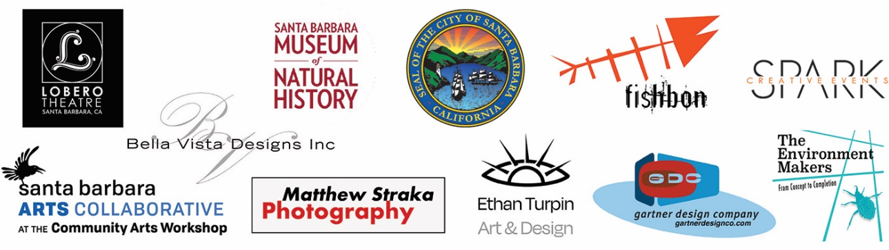

MEDIA RELEASE

SANTA BARBARA BUILDINGS “LIGHT IT BLUE”
IN SUPPORT OF HEALTHCARE & ESSENTIAL WORKERS

SANTA BARBARA, CA – 5/12/2020
On Thursday, May 14 at 8:00 PM, the Sea Center on Stearns Wharf, Arlington Theater Tower, Lobero Theatre, and Mission Tower will light up in blue to show gratitude to healthcare and essential workers as part of the international Light It Blue campaign. The City of Santa Barbara is collaborating with the Santa Barbara Arts Collaborative, community artists, event production companies, and the following organizations who donated time and equipment to light community buildings:

- Gartner Design Company
- The Environment Makers
- Ethan Turpin Art and Design
- Spark Creative Events (Arlington Theater Tower, Lobero Theatre, Cottage Hospital sites)
- Bella Vista Designs (Sea Center)
- Santa Barbara Museum of Natural History and Sea Center
- Lobero Theatre
- Arlington Theater
- Nina Dunbar
- Cottage Health System
- Mission Santa Barbara

This highly visible, public act of support is in partnership with the #LightItBlue campaign which invites businesses, venues, and communities to turn blue in support of the frontline medical staff and essential workers who are confronting the COVID-19 pandemic in hospitals, grocery stores, and other essential businesses around the world.

The Sea Center, Arlington Theater, Lobero Theatre, Santa Barbara Cottage Hospital, Goleta Valley Cottage Hospital, and Santa Ynez Valley Cottage Hospital and the Old Mission Santa Barbara will be the first buildings in Santa Barbara to be lit up in blue as part of this campaign. Other buildings are planned. With the exception of the Sea Center, lighting will remain up through the month of May.

The public is encouraged to admire the illuminated buildings from afar and avoid gathering at the sites, continuing the practice of maintaining social distancing to protect public safety and prevent the spread of COVID-19.

Mayor Cathy Murillo said, “I’m proud of the collaboration between our community artists and art organizations to honor the hard work and sacrifice of health care professionals and frontline employees. Thank you for providing the community with a lighting display to bring us all together.”

SBMNH President & CEO Luke J. Swetland shared, “We are so honored to participate in this important moment of recognition and appreciation. The Sea Center floats magically above our beautiful, blue Channel. Bathing it in calming light is a wonderful way to show our community’s love and support for those who are taking care of the most fragile among us.”

According to Executive Director David Asbell, “The Lobero has been a part of the Santa Barbara community for nearly 150 years, and we’re happy to show our support for all the health-care workers, first responders, and essential workers today. Thanks for all you’re doing.”

Special thanks to the Gartner Design Company, The Environment Makers, Ethan Turpin Art and Design, Bella Vista Designs, Sparks Creative Events and Nina Dunbar for their support of the project.

The #LightItBlue campaign started on March 26 when landmark and historic buildings in the United Kingdom were lit blue as a salute to healthcare providers responding to the COVID-19 public health crisis. Since then, hundreds of buildings, bridges, entertainment halls, and landmarks across the globe have joined in. For more information on the #LightItBlue campaign, visit makeitblue.us.

###

Contacts:

City of Santa Barbara
Contact: Nina Johnson, Senior Assistant to the City Administrator
Phone: (805) 564-5307
Email: NJohnson@SantaBarbaraCA.gov

Gartner Design Company
Contact: Andrew Gartner
Phone: (602) 751-1155
Email: Andrew@gartnerdesignco.com

Santa Barbara Museum of Natural History
Contact: Briana Sapp Tivey, Director of Marketing and Communication
Phone: (805) 682-4711
Email: BSappTivey@SBNATURE2.ORG

Lobero Theatre Foundation
Contact: Angie Bertucci, Marketing and Communications Director
Phone: (805) 679-6010
Email: ABertucci@Lobero.org

