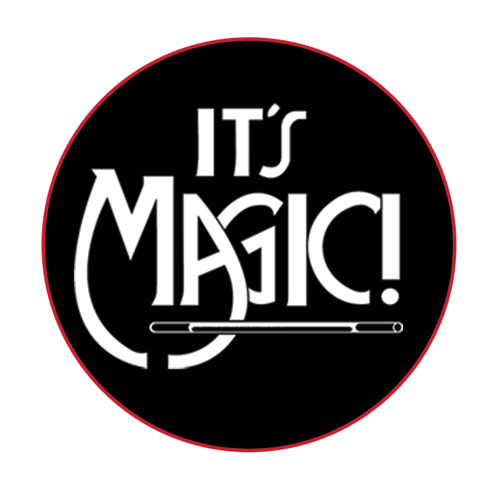
For Immediate Release

Media: Angie Bertucci / 805.679.6010 / abertucci@lobero.org

Tickets: Lobero Box Office / 805.963.0761 / lobero.org

Lobero LIVE presents IT’S MAGIC!
Rescheduled to Saturday, October 24
Two Performances at 2 PM & 6:30 PM

- This family-friendly performance will dazzle and delight audiences of all ages.
- Each year is a whole new show featuring talented performers representing a variety of magical disciplines.
- Reduced pricing for kids 12 & younger

Santa Barbara, CA, March 25, 2020 – Lobero LIVE is proud to welcome It’s Magic! back to the Lobero Theatre on Saturday, October 24 at 2 and 6:30 PM. Santa Barbara’s favorite comedy and magic revue returns to the Lobero to dazzle audiences with an all-new lineup of top illusionists direct from exotic showrooms and Hollywood’s famous Magic Castle. This one-of-a-kind magic show showcases different types of magic–from subtle sleight of hand to big-stage illusions. The colorful costumes and zany antics from this new crop of performers will have you glued to the edge of your seat! The 63rd Annual Edition of It’s Magic! will feature acclaimed magicians Christopher Hart, Nick Diffatte, David Zirbel, Michael & Hannah Ammar, and Richard Burr & Josette.

“The liveliest lineup of magic acts this side of Las Vegas!” – The Los Angeles Times

Tickets for It’s Magic! are on sale now at the Lobero Theatre Box Office, Lobero.org, or by calling 805.963.0761. Tickets are $44 -$34 for adults and $25 - $20 for children 12 & younger. Limited number of VIP tickets available for $85 which include premier seating and a reception before the 2 PM show only with pizza and ice cream. All VIP ticket buyers are invited to attend. Ticket prices include a per ticket Lobero Facility Fee; other fees may also apply.

Get your tickets today, before they disappear…

About It’s Magic!
The tradition of an all-star magic show started in 1956 when two young entrepreneurs, Milt Larsen and Oliver Berliner, produced a show called Hocus Pocus ‘56. At first, the shows played for a very limited time only, but as the number of fans grew, the number of performances was expanded. This gave Larsen the idea of forming a full-time venue for magicians and magic enthusiasts, and thus was born the Magic Castle, a private club which opened its doors in 1963. Terry Hill, a longtime Magic Castle member, made the point that magicians could be seen throughout the year at the Castle, but the public rarely had a chance to see these great performers. Also, the Castle had stage limitations and was restricted to audiences over twenty-one years of age. There was a real need for an exciting full evening family-friendly show like It’s Magic! Eventually, Larsen and Hill teamed up to bring It’s Magic! to theater venues across the country, and have been featuring well-known performers and magicians ever since.

Christopher Hart
After his featured role as “Thing,” the expressive, disembodied hand in the film The Addams Family and the sequel Addams Family Values, Christopher Hart became known as “the man with the movie star hand.” Since his acting debut, Christopher has created a multi-award-winning magic act set to music and performed for audiences in Japan, China, Germany, South America, and more. “I’ve found people and cultures all over the globe are fascinated with magic,” says Christopher. “It really is a universal art form that creates feelings of wonder and joy, and that’s why I do it."

Nick Diffatte
Nick Diffatte is quickly becoming one of the most talked about and in demand young comedians working today. His unique brand of entertainment seamlessly blends dry humor, quick wit, and incredible skill. His performances are presented with perfect comedic timing far beyond his years and deadpan delivery that will has audiences laughing uncontrollably from beginning to end. At the age of 23, Nick has already been a featured performer at the world-famous Magic Castle in Hollywood, appeared on The Late Late Show on CBS, won multiple awards for both his magic and his comedy, held multiple long-term residencies on the Las Vegas strip, headlined shows on Disney Cruise Line and performed at a multitude of casinos, comedy clubs, and international corporate events.

David Zirbel
Towering at a remarkable seven foot one, David is without a doubt taking magic to new heights. David started performing magic at nine years-old and by age thirteen, he had already become one of the youngest members of the Academy of Magical Arts Junior Society at the world-famous Magic Castle, as well as the youngest magician ever invited to join the International Guild of Prestidigitators. By the time he was twenty years-old, David had already developed, directed and choreographed several full evening shows and was touring Japan on a regular basis. Since then, David has completed nearly 30 tours of Japan and brought his act to China, Germany, Australia, Thailand, Canada, Malaysia, and some of the most notable magic venues in the United States. David combines comedy, theater, dance, mystery, classic illusion, props, live animals, and music to create an uplifting and exciting performance that audiences won’t want to miss.

Michael and Hannah Ammar
Michael's magic encompasses a full spectrum of performance genres: from very intimate, sleight-of-hand to stand-up "parlor" magic, and now more recently the stage with his mysterious Victorian illusion, "The Spirit Cabinet" with his wife Hannah. His disarming humor and casual poise only serve to make the impossibilities of his magic even more surprising and powerful. Hannah Ammar was born and raised in magic, as the daughter of Frances Willard and grand-daughter of Willard the Wizard. Her family is the oldest consecutive family of magicians still performing today. Together, Michael and Hannah have taken “The Spirit Cabinet” all over the country, including the Improv in Orlando; The Abbeville Opera House in South Carolina; and the Majestic Theater in Dallas.

Richard Burr & Josette
Richard & Josette are international masters of magic and illusion. Recently called the “Real Harry Potter” by BoxOffice Magazine, Richard and Josette are known globally for their impressive illusions and together hold five Guinness World Records. Richard’s card and coin manipulation has been seen on international televisions shows and commercials, and he is the only magician in history to achieve eight silver dollars rolling on both hands continuously. The two are frequent headliners at Magic Castle and have performed for major corporations like Walt Disney, Universal Studios, NBC, CBS, and more.

Tickets for It’s Magic! are on sale now at the Lobero Theatre Box Office, Lobero.org, or by calling 805.963.0761. Tickets are $44 -$34 for adults and $25 - $20 for children 12 & younger. Limited number of VIP tickets available for $85 which include premier seating and a reception before the 2 PM show only with pizza and ice cream. All VIP ticket buyers are invited to attend. Ticket prices include a per ticket Lobero Facility Fee; other fees may also apply.

# # #

Lobero LIVE and Lobero Youth & Community programs are sponsored by the Santa Barbara County Arts Commission, the Santa Barbara Independent, The Lobero Theatre Associates, and the Elaine F. Stepanek Foundation.
Calendar Editors, please note:
Saturday, October 24 at 2 & 6:30 PM
Lobero Theatre

Lobero LIVE presents
It’s Magic!
This family-friendly performance is sure to dazzle and delight audiences of all ages. It’s Magic! features an exciting new lineup of top magicians representing Hollywood’s Magic Castle and stages from across the world performing incredible feats of sleight-of-hand and mind-boggling illusions.

Tickets for It’s Magic! are on sale now at the Lobero Theatre Box Office, Lobero.org, or by calling 805.963.0761. Tickets are $44 -$34 for adults and $25 - $20 for children 12 & younger. Limited number of VIP tickets available for $85 which include premier seating and a reception before the 2 PM show only with pizza and ice cream. All VIP ticket buyers are invited to attend. Ticket prices include a per ticket Lobero Facility Fee; other fees may also apply.
https://www.lobero.org/events/its-magic-2020/

www.lobero.org, Lobero Box Office 805.963.0761, 33 East Canon Perdido Street, Santa Barbara, CA 93101

