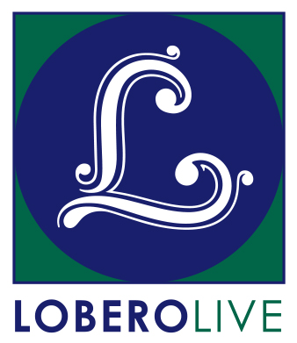
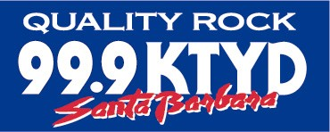
GO TO HALE: Quips & Clips
Music is Love: 1960’s - Present
Saturday, November 2 at 6:57 PM SHARP!

- Save $5 on tickets by purchasing before Oct 10

Santa Barbara, CA, September 16, 2019 – Rock ‘n roll fan and music lover Hale Milgrim is back with the highly anticipated return of Quips & Clips on November 2. Hale (aka, the Trip Master) has mined his personal archives for rare concert footage and insider stories. Thanks to a lot of help from his friends, he will lead a magical mystery tour of outstanding artists from the 60’s to the present and share rarely heard rock ’n roll stories. While we cannot reveal who will be the subject of many of the clips, don’t worry–you’re in for a very special evening.

Milgrim’s musical journey started behind the counter at Isla Vista’s Discount Records, and has spiraled upward through a succession of positions at major record labels, leading eventually to a stint as the President/CEO of Capitol Records. Since returning to Santa Barbara with his wife Anne, he has continued to work and support local music (including Sings Like Hell), and hosted a Sunday radio show, “Go to Hale,” which aired for over six years on KTYD.

“There are plenty of music mavens in Santa Barbara, but there’s only one Hale Milgrim.” – Santa Barbara Dependent

“Is there any doubt that Hale Milgrim should go down in history as one of the top 929 music fans in Santa Barbara History?” – Montecito Jurnal

“This is music that will last a lunchtime!” – The Rutles

“The best show I’ve never seen” – David Asbell

“OHNOTHIMAGAIN” – Hari Georgson/SBNOOZ

Audiences can look forward to memorable insights, commentary and illumination from Hale–well, at least everything he remembers… (or not!)

Tickets for Go To Hale Quips & Clips: Music is Love: 1960’s – Present, are on sale now at the Lobero Box Office at Lobero.org or by calling 805.963.0761. Single tickets are $15 each until 10/10/19, $20 thereafter. The presentation will begin at 6:57 PM sharp, and doors open at 6:27 PM. Seating is general admission, so be sure to get here beginning at 6:03 PM on the Esplanade for pre-show refreshments and fun stuff from Lobero LIVE and KTYD. Proceeds from these sales benefit live music at the Lobero Theatre.

Go to Hale enjoys generous sponsorship from KTYD 99.9 FM. Lobero LIVE is sponsored by the Santa Barbara County Arts Commission, and the Santa Barbara Independent. Funded in part by the Events and Festivals Program using funds provided by the City of Santa Barbara in partnership with the Santa Barbara County Office of Arts and Culture.

This Message Is Approved By Inhalemusic.net

# # #

Calendar Editors, please note:
Saturday, November 2 at 6:57 PM
Doors Open with preshow @6:27 PM
Lobero Theatre

GO TO HALE:
Quips & Clips: Music is Love
Saturday, November 2 at 6:57 PM

Rock ‘n roll fan and music lover Hale Milgrim is back with ANOTHER carefully-crafted show, one that will never be duplicated. Featuring rare concert footage and insider stories with some (OK, a lot) of help from his friends. Join Hale for a visual, musical journey over the last 60 years complete with his memorable insights, and a few things that he actually remembers.

Please note: Content is subject to change without warning.

Tickets: $15, General Admission until 10/10/19, $20 thereafter. Includes facility fee.

Lobero Box Office: www.Lobero.org, 805.963.0761, 33 East Canon Perdido Street, Santa Barbara, CA 93101

