

FOR IMMEDIATE RELEASE

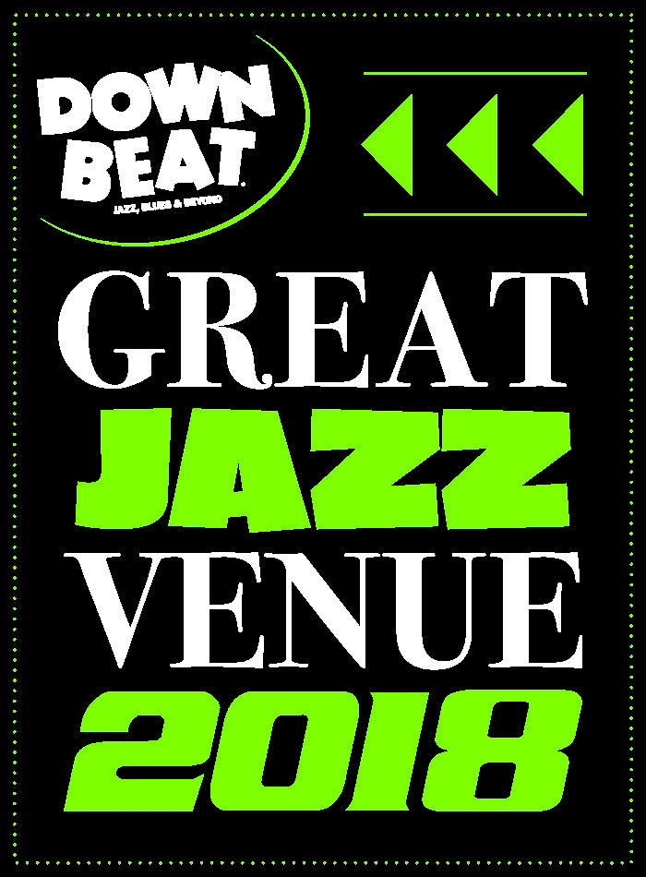Media: Angie Bertucci 805.679.6010 / [abertucci@lobero.org](mailto://abertucci@lobero.org)

Tickets: Lobero Box Office 805.963.0761 / [lobero.org](http://www.lobero.org)

**Jazz at the Lobero presents**

**Dorado Schmitt & Django Festival All-Stars**

Tuesday, November 20 at 8 PM

“The hardest swinging band at the Newport Jazz Festival.” – *Downbeat Magazine*

*Santa Barbara, CA, November 15, 2018* – [Jazz at the Lobero](https://www.lobero.com/series/jazz-at-the-lobero/) presents gypsy jazz genius Dorado Schmitt and the Django Festival All-Stars on Nov 20 as the final event in the Fall Jazz at the Lobero series. Gypsy jazz genius Dorado Schmitt and his all-star ensemble follow in the footsteps of Django Reinhardt and Stephane Grappelli, taking hot-swing jazz beyond with their virtuosity, original compositions and hip improvisations.

Hot Jazz harkens back to the 30's and 40's in Europe where Django Reinhardt teamed with top jazz violinist Stephane Grappelli to create The Hot Club Quintette of France–the greatest musical partnership in European history Jazz history. This hot-swing form of jazz has its roots in American popular music in the reverence for Duke Ellington, Louis Armstrong, and other top American jazz figures of the time. Each of the All-Stars are composers in their own right and while this music can harken back to the great music of the past, their interpretations, arrangements, virtuosity, and original compositions bring a newness to Django's style and take it beyond.

The Django Festival All-Stars are the best players to come out of the Django Reinhardt Festival, led by legendary gypsy guitarist/violinist Dorado Schmitt. These world class musicians hail mostly from France, and frequently headline The Django Reinhardt Festival at the legendary music club Birdland in New York City, and tour prestigious halls across the country such as Rose Hall/Jazz at Lincoln Center, Disney Hall, The Kennedy Center, Lincoln Center, The San Francisco Festival, and many more.

**Tickets for Dorado Schmitt & the Django Festival All-Stars are on sale at** [**Lobero.org**](https://checkout.lobero.com/subscription/packageDetail.aspx?pkg=648&flex=N&nfs=N) **or by calling the Box Office at 805.963.0761.** Series Tickets are available for $105 (VIP), $49 (Section A), $39 (Section B). VIP ticket buyers can look forward to pre-show receptions before each concert with complimentary appetizers and bar. Jazz at the Lobero subscribers enjoy priority seating, savings on single ticket prices, and advance notice for all upcoming jazz shows. Learn more by calling the Lobero Box Office at 963.0761.

Brubeck Circle Members enjoy an exclusive 20% discount on all Jazz at the Lobero shows–even those offered outside the series. The Lobero Brubeck Circle makes it possible for the Lobero to bring amazing jazz, blues and roots artists to the Lobero stage and supports efforts to create the jazz audiences of tomorrow through educational outreach programs. Learn more about the Lobero Brubeck Circle at [Lobero.org/Jazz](http://www.lobero.org/tickets/jazz/) and become a member by designating a gift of $100 or more to jazz at [Lobero.org/Donate](http://checkout.lobero.com/dev/contribute.aspx).

# # #

Lobero LIVE is sponsored by the Santa Barbara County Arts Commission, the *Santa Barbara Independent* and KCSB 91.9 FM. Lobero LIVE is funded in part by the Events and Festivals Program using funds provided by the City of Santa Barbara in partnership with the Santa Barbara County Arts Commission. Sponsorship for Jazz at the Lobero is provided by the Lobero Theatre Endowment for American Roots Music, *Voice Magazine*, and the Lobero Brubeck Circle of Donors.