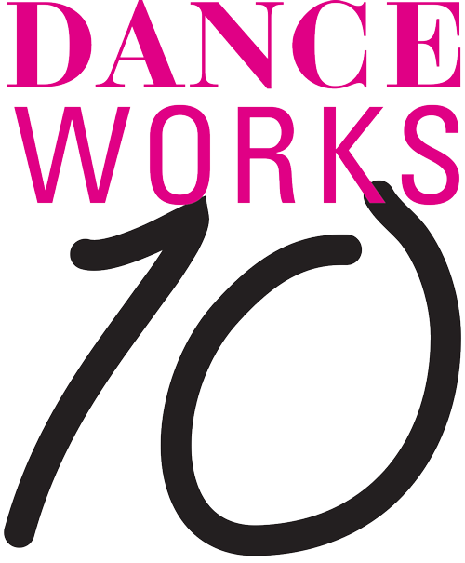
For Immediate Release
Media Contact: Angie Bertucci abertucci@lobero.com / 805.679.6010

DANCEworks Welcomes Doug Elkins for 2018 Residency and
Celebrates a Decade of Dance Innovation!

Residency Begins Aug 13. Performances Sept 7 & 8 at the Lobero Theatre
Performance features past DANCEworks alum: Aszure Barton, Brian Brooks, Larry Keigwin, Mark Dendy, Adam Barruch, Shannon Gillen, Kate Weare, and Doug Varone (special guest)

Santa Barbara, CA, June 22, 2018 – DANCEworks welcomes celebrated choreographer Doug Elkins back to the Lobero for their landmark 10th Anniversary Season this August. Elkins is regarded as the first choreographer to successfully blend together street dance, ballet and modern dance, and is a recipient of significant choreographic commissions and awards. Elkins has been hailed by The New York Times as, “one of the most musical, witty and inventive choreographers of his generation.” While in residence, Elkins and his company will create a new work exploring the Japanese practice of kintsugi, or noble scarring.

Throughout Elkins’ residency, DANCEworks’ Friday Club members will get exclusive access to see the ambitious new work come together live onstage and engage in lively discussions with the company. Join the club by making a contribution of $150 or more at SBDANCEworks.com. DANCEworks’ Friday Club returns for three sessions this year: August 17, 24 & 31 at the Lobero Theatre.

“I am eager for the opportunity to return to the Lobero for the DANCEWorks residency. First, there is beautiful Santa Barbara. And second and third, there is time and focus to create. We are so lucky!”
– Doug Elkins, DANCEworks 2018 Choreographer-in-residence

A Decade of Dance Innovation
For this special 10th Anniversary Celebration, DANCEworks has invited the cast of choreographers back to the Lobero Theatre for the second half of the performances on September 7 &8th. DANCEworks alum Larry Keigwin (Bolero Santa Barbara), Brian Brooks (BIG CITY), Aszure Barton (Busk), Mark Dendy (Dystopian Distractions), Adam Barruch (Sweeney Todd), Shannon Gillen (Future Perfect) and Kate Weare (Sin Salida) Doug Varone, our first SUMMERDANCE artist, will be performing in a tour de force of modern dance.

Tickets for the DANCEworks Decade of Dance celebration are on sale now at Lobero.org. Limited number of VIP tickets available for $105, which includes entry to post-performance reception & commemorative book. Section A $40 / Section B $25 / Students $15.

ABOUT THE COMPANY
doug elkins choreography, etc. was established in summer 2009 as a way to brand independent dance, theater, and teaching projects for Doug Elkins. The umbrella has allowed for the creation of award-winning works including Fräulein Maria, a loving deconstruction of The Sound of Music; Mo(or)town/Redux, a movement conversation with Shakespeare’s Othello and Jose Limon’s seminal The Moor’s Pavane set to a Motown-inspired score commissioned by DANCEworks Santa Barbara; and Hapless Bizarre, a 2013 National Dance Project selection.

Doug Elkins is a two-time New York Dance and Performance (Bessie) Award-winning choreographer and 2012 John Simon Guggenheim Memorial Foundation Creative Arts Fellow. He began his dance career as a B-Boy, touring the world with break dance groups New York Dance Express and Magnificent Force, among others. A graduate of SUNY/Purchase, Elkins received his MFA in Dance from Hollins University/ADF in 2007. In fall 2013, he became a full-time faculty member at Mason Gross School of the Arts at Rutgers University, the State University of New Jersey. For the spring 2015 season at Lincoln Center and subsequent national touring, Elkins was commissioned by Paul Taylor American Modern Dance to create The Weight of Smoke. Most recently, Montclair State University’s Office of Arts and Cultural Programming, under the direction of Jed Wheeler, commissioned A Hundred Indecisions, a film conceived and directed by Elkins, and O, round desire, an ensemble piece for five dancers.

PRESS QUOTES
“Doug Elkins is one of the most musical, witty and inventive choreographers of his generation.” – Roslyn Sulcas, The New York Times (12/23/07)

“[This] searing production is remarkable for its seamlessness… Mr. Elkins tells this story with the ease of a magician.” – Gia Kourlas, The New York Times (1/8/15)

About DANCEworks
DANCEworks is an innovative collaboration between SUMMERDANCE Santa Barbara and the Lobero Theatre Foundation designed to offer notable choreographers in the USA a month-long residency in which to create, rehearse and premiere the new work on the Lobero stage. Over the last 10 years DANCEworks has provided valuable opportunities for our nation’s most talented choreographers to make new work in a congenial supportive environment, putting Santa Barbara on the map as a community that supports the creation of new choreography in a significant way. DANCEworks has already contributed to the careers of several groundbreaking choreographers: Aszure Barton, Larry Keigwin, Doug Elkins, Brian Brooks, Mark Dendy, Adam Barruch, Shannon Gillen, and Kate Weare.

# # #

DANCEworks is sponsored by National Endowment for the Arts (ART WORKS) in addition to generous support by The Towbes Family Endowment for Dance, The Towbes Foundation, and the Dianne & Daniel Vapnek Family Foundation. DANCEworks is funded in part by the Events and Festivals Program using funds provided by the City of Santa Barbara in partnership with the Santa Barbara County Office of Arts and Culture, and by the Santa Barbara Independent.

