DUE TO POPULAR DEMAND
ANTHONY JESELNIK ANNOUNCES MORE FUNNY GAMES TOUR 2018 NORTH AMERICAN DATES

On Sale Friday, July 20 at 10am
At Livenation.com

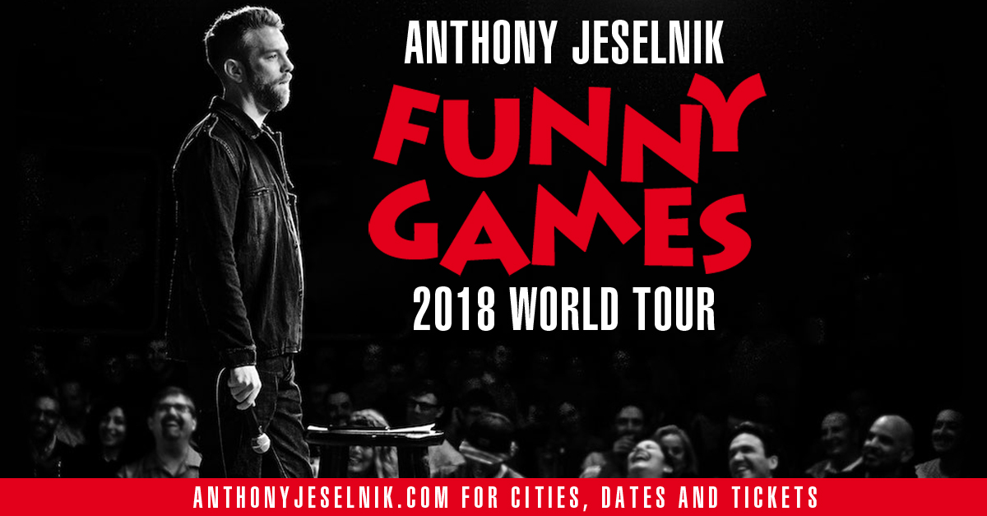

Los Angeles, CA (July 16, 2018) – Due to popular demand renowned comedian Anthony Jeselnik is adding more shows to his hit 2018 tour: Funny Games. After selling out over 40 theaters, this leg of the tour kicks off on September 13 in Spokane, WA. Shows will continue to feature new material from the comedy superstar! You don’t want to miss him. Tickets are on sale Friday, July 20 at 10am at LiveNation.com.

Jeselnik is a comedy industry veteran wowing audiences for over 15 years. 2017 was a banner year for Anthony as he toured with Chris Rock's Total Blackout tour and perfected his new hour, workshopping in clubs across North America. He started his comedy career by starring in and creating Comedy Central’s THE JESELNIK OFFENSIVE, which ran for two seasons. He went on to write and appear for several Comedy Central Roasts, most notable: THE ROAST OF DONALD TRUMP and THE ROAST OF CHARLIE SHEEN. Anthony was the first ever stand-up comic to appear on Late Night with Jimmy Fallon. He also wrote for Late Night with Jimmy Fallon as well as received an Emmy Nomination for his work on A NIGHT OF TOO MANY STARS: AN OVERBOOKED CONCERT FOR AUTISTIC EDUCATION. In 2008 Jeselnik was named as one of Variety’s 10 Comics to Watch, and in 2009 was named Comedy Central’s Hot Comics. In 2010, Anthony released his debut comedy album SHAKESPEARE through Comedy Central Records. In 2013, he released CALIGULA, his first hour long special, to critical acclaim. Jeselnik hosted season nine of NBC’s LAST COMIC STANDING alongside judges Norm Macdonald, Roseanne Barr and Keenan Ivory Wayans. His last official tour was in 2014 and ended in early 2015 when he shot his critically acclaimed Netflix special THOUGHTS AND PRAYERS.

The current tour routing can be found below:

ANTHONY JESELNIK FUNNY GAMES TOUR 2018
Date | Venue | City, State
9/13/18 | Bing Crosby Theater | Spokane, WA
9/14/18 | MacEwan Hall | Calgary, AB
9/15/18 | Myer Horowitz Theatre | Edmonton, AB
9/20/18 | Modell Performing Arts Center at The Lyric | Baltimore, MD
9/21/18 | College Street Music Hall | New Haven, CT
9/22/18 | The Music Hall | Portsmouth, NH
9/27/18 | Babs Asper Theatre - National Arts Centre | Ottawa, ON
9/28/18 | Sony Centre for the Performing Arts – JFL42 | Toronto, ON
9/29/18 | Centennial Hall | London, ON
10/11/18 | Fountain Street Church | Grand Rapids, MI
10/13/18 | Hoyt Sherman Place | Des Moines, IA
10/25/18 | 20th Century Theater | Cincinnati, OH
11/1/18 | Balboa Theatre | San Diego, CA
11/2/18 | City National Grove of Anaheim | Anaheim, CA
11/3/18 | Lobero Theatre | Santa Barbara

About Live Nation Entertainment
Live Nation Entertainment (NYSE: LYV) is the world's leading live entertainment company comprised of global market leaders: Ticketmaster, Live Nation Concerts, and Live Nation Media & Sponsorship. For additional information, visit www.livenationentertainment.com.

