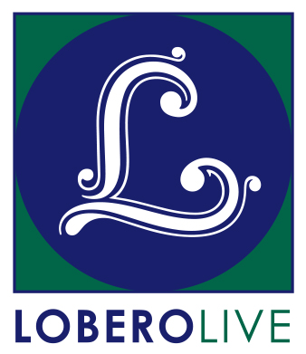
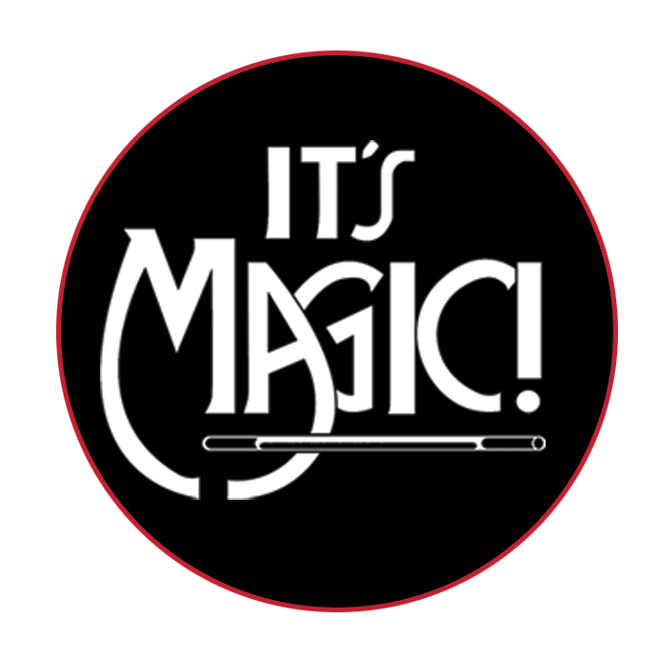
For Immediate Release

Media Contact: Angie Bertucci
805.679.6010 / abertucci@lobero.org

Tickets: Lobero Box Office
805.963.0761 / lobero.org

Lobero LIVE presents IT’S MAGIC!
Saturday, March 31 at 2 PM & 6:30 PM

America’s longest-running magic revue celebrates 20 years of comedy and magic at the Lobero Theatre

Santa Barbara, CA, March 8, 2018 – Lobero LIVE is proud to welcome It’s Magic! back to the Lobero Theatre on Saturday, March 31 at 2 and 6:30 PM. America’s longest-running magic revue returns to the Lobero to dazzle audiences with an all-new lineup of top illusionists direct from exotic showrooms and Hollywood’s famous Magic Castle. The 62nd Annual Edition of It’s Magic! will Feature: Xavier Mortimer, Chuck Jones & Co., Dan Birch, Pop Hayden and Matt Marcy. This one-of-a-kind magic show that has been delighting comedy and magic fans in Santa Barbara for more 20 years at the Lobero Theatre.

“The liveliest lineup of magic acts this side of Las Vegas!” – The Los Angeles Times

It’s Magic! will be appearing at the Lobero Theatre on March 31 for two performances. Tickets are on sale now at the Lobero Theatre Box Office, Lobero.org, or by calling 805.963.0761. Tickets are $20 for children, and $29 section B/ $35 section A for adults, with a limited number of VIP tickets available at $80. All prices include facility fee. VIP tickets include priority seating, and entry to a private reception before the 2 PM performance.

Get your tickets today, before they disappear…

About It’s Magic!
The tradition of an all-star magic show started in 1956 when two young entrepreneurs, Milt Larsen and Oliver Berliner, produced a show called Hocus Pocus ‘56. At first, the shows played for a very limited time only, but as the number of fans grew, the number of performances was expanded. This gave Larsen the idea of forming a full-time private club for magicians and magic enthusiasts, and thus was born the Magic Castle, a private club for magicians and magical enthusiasts that opened its doors in 1963. Terry Hill, a longtime Magic Castle member, made the point that although magicians could be seen throughout the year at the Castle, the public rarely had a chance to see these great performers. Also, the Castle had stage limitations and was restricted to audiences over twenty-one years of age. There was a real need for an exciting full evening family-friendly show like It’s Magic!

DAN BIRCH
Dan Birch's magical career is no illusion! After almost twenty years, this one-of-a-kind Magician hasn't exactly pulled his entertainment success out of a hat! He took the leap from reality to the supernatural at age twelve by way of one medium: alchemy. Forecasting natural events, Dan transcends rational explanation producing pure enchantment. His high-tech magic style shaped by his dramatic looks, skillfully mixed with flash, laser lights and live animals naturally solves the inexhaustible question, "Do You believe in Magic?" Dan Birch resurrected the notion of a "real Magician" by embracing the apparel and apparatus of the stereotypical Magician in a unique & modern way. Dubbed ''The Lord of Illusions", in one of his most famous acts he makes live doves appear and transform into a live poodle all this in the blink of an eye, leaving the audience mesmerized and pondering, “how did he do that?"

WHIT "POP" HAYDN
Whit "Pop" Haydn was named Stage Magician of the Year in March, 2015 at the world famous Magic Castle in Hollywood. He is the winner of seven performer of the year awards from the Magic Castle, the clubhouse of the Academy of Magical Arts. In February 2006, he became Vice-President of that organization, and served for four years in that capacity.

CHUCK JONES & CO
Chuck Jones’ career in magic has been long and successful, building an enviable track record that covers nearly every phase of show business, from revue shows including Caesar’s Palace and MGM Grand to fairs and expositions, television, corporate shows, amusement park productions, mall and touring shows. The illusionist has entertained since the age of 12, when he appeared as a magician with Johnny Carson. Chuck Jones & Co. have received the prestigious Performing Fellowship Award from Hollywood’s world famous Magic Castle in addition to the Showmanship Award from the Society of American Magicians. He and his wife, Jan have received a Dragon Award, which is presented to a husband and wife team who excel in six different areas of magic. Whether making magic on stage or off, Chuck Jones is one of America’s busiest and most versatile magicians today and, most likely, will be creating his special brand of legerdemain for many years to come.

MATT MARCY
Matt Marcy has spent the last 15 years performing around the world as a comic-magician and emcee. With over 3,000 shows under his belt, he's entertained everyone from Hollywood celebrities to CEO's of Fortune 500 companies to royalty. Matt has made a name for himself by combining his unique style, quick wit, and completely original magic and illusion, and is a regular entertainer for corporate and private events, as well as for clubs, theaters, hotels, casinos, colleges, and cruise ships. He is also a favorite at the world-famous Magic Castle in Hollywood, having performed over 1,000 shows at the exclusive magicians' clubhouse.

XAVIER MORTIMER
Raised in southwestern France, Xavier Mortimer packed up his suitcase and now travels the world while creating shows that blend magic, circus acts, music and comedy. Xavier Mortimer studied at the Music and Dance Conservatory of La Rochelle, as well as the Desmond Jones Acting School in London and the Jacques Lecoq Acting School in Paris. At the age of 15, he created his first show, a combination of magic, mime and comedy. Thereafter, he began collecting several prizes for Magic (1st place at the Albano International Congress in Italy, Gold Star at the L’Eau d’Olle magic festival in France) and several more international prizes for. He currently headlines his own show on the Las Vegas strip while touring internationally and appears on TV shows all around the world.

Tickets for It’s Magic! are available now at Lobero.org, and at the Lobero Theatre Box Office by calling 805.963.0761. Tickets are $20 for children, and $29 section B/ $35 section A for adults, with a limited number of VIP tickets available at $80. All prices include facility fee. VIP tickets include priority seating, and entry to a pre-performance private reception before the show (2 PM performance only).

# # #

Lobero LIVE and Lobero Youth & Community programs are sponsored by the Santa Barbara County Arts Commission, the Santa Barbara Independent, Montecito Bank & Trust, The Lobero Theatre Associates, Union Bank, Elaine F. Stepanek Foundation, Brown Family Foundation, Harold McAlister Charitable Foundation, Nichols Foundation
Calendar Editors, please note:
Saturday, March 31 at 2 & 6:30 PM
Lobero Theatre

Lobero LIVE presents
It’s Magic!
America’s longest-running magic revue returns to the Lobero to dazzle audiences with an all-new lineup of top illusionists direct from exotic showrooms and Hollywood’s famous Magic Castle.

Tickets for It’s Magic! start at $20/Children, $29-$35/Adults & a limited number of VIP tickets available for $80. Prices include facility fee. https://www.lobero.org/events/its-magic-2018/

www.lobero.org, Lobero Box Office 805.963.0761, 33 East Canon Perdido Street, Santa Barbara, CA 93101

