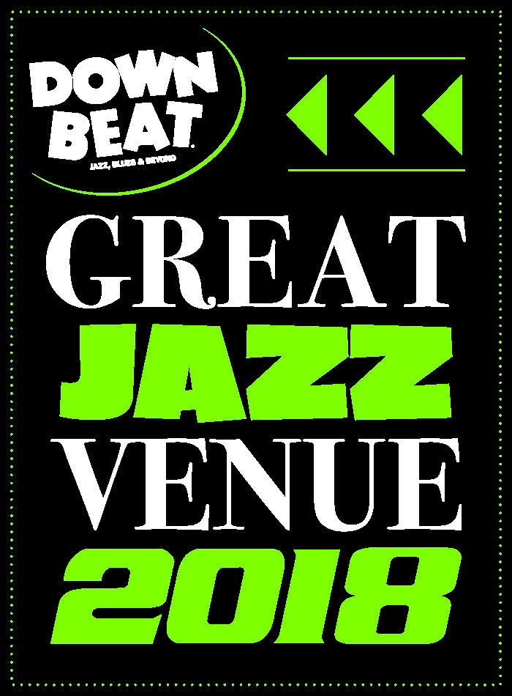

FOR IMMEDIATE RELEASE

Press Contact: Angie Bertucci 805.679.6010 [abertucci@lobero.org](mailto:abertucci@lobero.org)

Tickets: Lobero Box Office

805.963.0761 or [lobero.org](http://www.lobero.org/)

**Jazz at the Lobero presents  
CHARLES LLOYD AND FRIENDS,**

**An 80th Birthday Celebration**

featuring Gerald Clayton, Reuben Rogers, and Eric Harland

+ Julian Lage, Guitar and special guest Booker T Jones

Thursday, March 15 at 8 PM

Santa Barbara, CA, *February 26, 2018 –* Jazz at the Lobero is thrilled to present Charles Lloyd & Friends on Thursday, March 15 to celebrate his 80th Birthday with an evening that spans the colorful arc of his life in music – from Memphis and the Mississippi Delta with Booker T. Jones to the universe beyond with Gerald Clayton, Julian Lage, Reuben Rogers, Eric Harland, and other special guests.

Saxophonist Charles Lloyd is a forward thinking “musician’s musician” His supreme improvisational talents and journies into rock and non-Western styles of music during the ‘60s and ‘70s established him as one of the key figures in the development of fusion and world music. The critical consensus is that Charles Lloyd has never sounded better. The depth of his expression reflects a lifetime of experience. Over nearly five decades, his compositions have punctuated the post-bop period, embraced the traditional music of a host of world cultures and enlivened the psychedelic 1960s with avant-garde improvisation. Lloyd was one of the first jazz artists to sell a million copies (*Forest Flower)*, and then he surprised the music world by walking away from performing just at the point that he was dubbed a jazz superstar. In 1970, Lloyd disbanded the quartet and dropped from sight, withdrawing to pursue an inner journey in Big Sur–the wild haven that had previously attracted other artists and seekers including Langston Hughes, Henry Miller, Lawrence Ferlinghetti, Jack Kerouac, Jean Varda and Jamie DeAngulo.

More than twenty years later, he is still in search of the “sound” and the truth. In 2014 Lloyd was honored as a Monterey Jazz Festival Jazz Legend, and in 2015 he received the NEA Jazz Master Award. In January 2016, he was honored by the [Lobero Theatre Ghostlight Society](https://www.lobero.com/giving/foundation/ghostlight/) as their first Artistic Luminary. Charles Lloyd maintains an active performance and recording schedule with the New Quartet, Sangam, Maria Farantouri and special projects around the world.

**Tickets for are on sale now** [**Charles Lloyd and Friends, an 80th birthday celebration**](https://www.lobero.org/events/charles-lloyd-friends/) **at** [**Lobero.com**](http://checkout.lobero.com/single/SelectSeating.aspx?p=10898) **or by calling the Box Office.** VIP Tickets are $125, Section A tickets are $64 & Section B are $54, including facility fees. VIP ticketholders enjoy premier seating and can look forward to an exclusive VIP reception before the performance.

Coming Up from Lobero LIVE:

***It’s Magic!***

**Saturday, March 31 at 2 & 6:30 PM**

America’s longest-running magic revue returns to the Lobero to dazzle audiences with an all-new lineup of top illusionists direct from exotic showrooms and Hollywood’s famous Magic Castle. <https://www.lobero.org/events/its-magic-2018/>

**Marc Cohn Trio**

**Tuesday, April 10 at 8 PM**

After winning a GRAMMY award for his soulful ballad “Walking in Memphis,” Marc Cohn solidified his place as one of this generation’s most compelling singer/songwriters, combining the precision of a brilliant tunesmith with the passion of a great soul man. <https://www.lobero.org/events/marc-cohn/>

**The Capitol Steps**

**Monday, May 8 at 8 PM**

Get ready for hilarious political comedy from the troupe that put the “mock” in “democracy.” No one in the headlines is safe from the sidesplitting satire of the Capitol Steps, the only group in Washington attempting to be funnier than Congress. <https://www.lobero.com/events/the-capitol-steps/>

**Jay Farrar Duo (Son Volt) with Johnny Irion**

**Tuesday, May 22 at 8 PM**

As a founder of alternative country pioneers Uncle Tupelo, a solo artist, and as the leader of Son Volt, Jay Farrar has been a keen observer of the American landscape. Most recently, Farrar has added the Son Volt album, Notes of Blue, to his long list of critically acclaimed albums. <https://www.lobero.org/events/jay-farrar-son-volt/>

# # #

Sponsorship for Jazz at the Lobero is provided by the Santa Barbara County Arts Commission, the *Santa Barbara Independent*, the Lobero Theatre Endowment for American Roots Music, *CASA Magazine*, Deckers Outdoor Corporation, and KCSB 91.9 FM and the Brubeck Circle of Donors. Lobero LIVE is funded in part by the Events and Festivals Program using funds provided by the City of Santa Barbara in partnership with the Santa Barbara County Arts Commission.

**­Calendar Editors, please note:**

**Thursday, March 15**

**Lobero Theatre**

**Jazz at the Lobero presents**

**Charles Lloyd & Friends, An 80th Birthday Celebration**

**Featuring Gerald Clayton, Reuben Rogers, and Eric Harland + Julian Lage, Guitar and Special guest Booker T Jones**

In celebration of his 80th birthday, Charles Lloyd presents an evening that spans the colorful arc of his life in music – from Memphis and the Mississippi Delta with Booker T. Jones to the universe beyond with Gerald Clayton, Julian Lage, Reuben Rogers, Eric Harland, and other special guests. <https://www.lobero.org/events/charles-lloyd-friends/>

*Tickets: $125 – VIP / $64 – Section A / $54 – Section B. Prices include facility fee.*

Lobero Box Office: www.Lobero.org, 805.963.0761, 33 East Canon Perdido Street, Santa Barbara, CA 93101