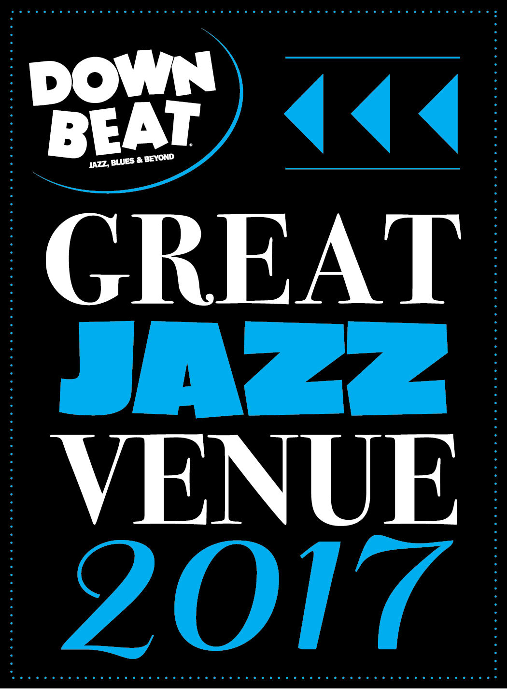

FOR IMMEDIATE RELEASE

Media: Angie Bertucci 805.679.6010 / [abertucci@lobero.org](mailto://abertucci@lobero.org)

Tickets: Lobero Box Office 805.963.0761 / [lobero.org](http://www.lobero.org)

Jazz at the Lobero presents Brad Mehldau

Saturday, October 28 at 8 PM

• Celebrated pianist to perform in solo format, and will play selections from his diverse catalog

• Part of the Jazz at the Lobero Fall Series

*Santa Barbara, CA, October 11, 2017* – [Jazz at the Lobero](https://www.lobero.com/series/jazz-at-the-lobero/) welcomes Brad Mehldau back to the Lobero Theatre on Saturday, October 28 at 8 PM as part of the Jazz at the Lobero Fall series. Brad Mehldau will perform solo in an evening highlighting his dexterity as an artist who crosses from jazz into classical and pop music with ease. He is one of the most lyrical and intimate voices of contemporary jazz piano, forging a unique path that embodies the essence of jazz exploration, classical romanticism and pop allure. Closing out this series will be 10 Time GRAMMY® Award Winner [Arturo Sandoval](https://www.lobero.org/events/arturo-sandoval/) on Dec 6, a disciple of Dizzy Gillespie who mixes in elements of his Cuban upbringing into his exciting live shows.

Mehldau’s musical personality forms a dichotomy. He is first and foremost an improviser, and greatly cherishes the surprise and wonder that can occur from a spontaneous musical idea that is expressed directly, in real time. But he also has a deep fascination for the formal architecture of music, and it informs everything he plays. In his most inspired playing, the actual structure of his musical thought serves as an expressive device. As he plays, he listens to how ideas unwind, and the order in which they reveal themselves. Each tune has a strongly felt narrative arch, whether it expresses itself in a beginning, an end, or something left intentionally open-ended. The two sides of Mehldau’s personality—the improviser and the formalist—play off each other, and the effect is often something like controlled chaos.

Mehldau has performed around the world at a steady pace since the mid-1990s’, with his trio and as a solo pianist. His performances convey a wide range of expression. There is often an intellectual rigor to the continuous process of abstraction that may take place on a given tune, and a certain density of information. That could be followed by a stripped down, emotionally direct ballad. Mehldau favors juxtaposing extremes. He has attracted a sizeable following over the years, one that has grown to expect a singular, intense experience in his performance.

**“Mehldau is the most influential jazz pianist of the last 20 years.” – *The New York Times***

**“Universally admired as one of the most adventurous pianists to arrive on the jazz scene in years.” – *The Los Angeles Times***

Tickets for [Brad Mehldau](https://www.lobero.org/events/brad-mehldau/) are on sale now at [Lobero.org](http://checkout.lobero.com/single/SelectSeating.aspx?p=10583) or by calling the Box Office at 805.963.0761. Tickets are $52 for Section A and $42 for Section B, with a limited number of VIP tickets available for $105. VIP ticket includes premier seating and a pre-show reception in the Lobero Courtyard at 7 PM with complimentary bar and hors d’oeuvres. Series Subscribers enjoy priority seating, savings of almost 20% on single ticket prices, and advance updates on upcoming shows. Learn more by calling the Lobero Box Office at 963.0761.

*DownBeat Magazine* has recognized the Lobero Theatre in their 2017 [guide to Great Jazz Venues](http://downbeat.com/digitaledition/2017/spcvenueguide/56-57.html). This is the Lobero’s seventh year on this prestigious list – which also includes venerable institutions such as the Blue Note, Preservation Jazz Hall and Yoshi’s. From its incredible inaugural season in 2000, that featured Chick Corea, Wynton Marsalis, Wayne Shorter and Herbie Hancock on through groundbreaking performances by the Preservation Hall Jazz Band last year, Jazz at the Lobero has provided a wealth of memorable musical moments.

Brubeck Circle Members enjoy an exclusive 20% discount on all Jazz at the Lobero shows–even those offered outside the series. The Lobero Brubeck Circle makes it possible for the Lobero to bring amazing jazz, blues and roots artists like Wayne Shorter, Dr. John, Chris Thile, Robert Cray, and Keb’ Mo’ to the Lobero stage. This core group of donors also supports efforts to create the jazz audiences and fans of tomorrow through educational outreach programs. Learn more about the Lobero Brubeck Circle at [Lobero.org/Jazz](http://www.lobero.org/tickets/jazz/) and become a member by designating a gift of $100 or more to jazz at [Lobero.org/Donate](http://checkout.lobero.com/dev/contribute.aspx).

COMING UP FROM JAZZ AT THE LOBERO

Jazz at the Lobero presents

[Arturo Sandoval](https://www.lobero.org/events/arturo-sandoval/)

Wednesday, December 6

A protégé of the legendary jazz master Dizzy Gillespie, Arturo Sandoval was born in Artemisa, a small town in the outskirts of Havana, Cuba, on November 6, 1949, just two years after Gillespie became the first musician to bring Latin influences into American Jazz. *\*Part of the Fall Jazz Series*

Jazz at the Lobero presents

[Charles Lloyd and Friends: An 80th Birthday Celebration](https://www.lobero.org/events/charles-lloyd-friends/)

Thursday, March 15

In celebration of his 80th birthday, Charles Lloyd presents an evening that spans the colorful arc of his life in music – from Memphis and the Mississippi Delta with Booker T. Jones to the universe beyond with Gerald Clayton, Julian Lage, Reuben Rogers, Eric Harland, and other special guests.

# # #

Lobero LIVE is sponsored by the *Santa Barbara Independent* and KCSB 91.9 FM. Lobero LIVE is funded in part by the Events and Festivals Program using funds provided by the City of Santa Barbara in partnership with the Santa Barbara County Office of Arts & Culture. Additional sponsorship for Jazz at the Lobero is provided by the Lobero Theatre Endowment for American Roots Music, *Voice Magazine*, and the Lobero Brubeck Circle of Donors.

**­Calendar Editors, please note:**

**Saturday, October 28 at 8 p.m.**

**Lobero Theatre**

**Brad Mehldau**

**Saturday, October 28**

One of the most lyrical and intimate voices of contemporary jazz piano, Brad Mehldau has forged a unique path that embodies the essence of jazz exploration, classical romanticism and pop allure. Mehldau continues to earn critical acclaim as a bandleader and for his collaborations with icons such as Pat Metheny, Renee Fleming, and Joshua Redman. <https://www.lobero.org/events/brad-mehldau/>

*Tickets: $105 – VIP / $52 – Section A / $42 – Section B. Prices include facility fee.*

Lobero Box Office: www.Lobero.org, 805.963.0761, 33 East Canon Perdido Street, Santa Barbara, CA 93101