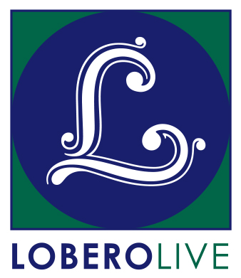
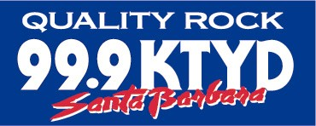
GO TO HALE: Film Series 2
Bill Graham: His Friends… and his Enemies
Fillmore: The Last Days
Friday, October 20 at 6:57 PM

Santa Barbara, CA, September 18, 2017 – Rock ‘n roll fan and music lover Hale Milgrim is back with ANOTHER carefully-crafted series of special evenings featuring rare concert footage and insider stories with some (OK, a lot) of help from his friends. Join Hale for a visual, musical journey over the last 50 years complete with his memorable insights, commentary and illumination. Or not.

On Friday, October 20, Hale will present the phenomenal concert film, Fillmore: The Last Days as only he can. Recorded at the Fillmore West in San Francisco from June 29 to July 4, 1971, the film contains performances by bands including SANTANA, THE GRATEFUL DEAD, JEFFERSON AIRPLANE, HOT TUNA, QUICKSILVER MESSENGER SERVICE, and the NEW RIDERS OF THE PURPLE SAGE among many others. Legendary concert promoter Bill Graham brought together some of the biggest acts of the 60’s on through the 90’s, and became a central figure in rock and roll. Come for the Fillmore lore; stay for more Quips & Clips highlighting rare “Bill Graham Presents” performances. Please note: Content is subject to change without warning.

Milgrim’s own musical journey started behind the counter at Isla Vista’s Discount Records, and has spiraled upward through a succession of positions at major record labels, leading eventually to a stint as the President/CEO of Capitol Records. Since returning to Santa Barbara with his wife Anne, he has continued to work and support local music (including Sings Like Hell), and hosted a Sunday radio show, “Go to Hale,” which aired for over six years on KTYD.

Tickets for the Go To Hale Film Series 2 are on sale now at the Lobero Box Office at Lobero.org or by calling 805.963.0761. Single tickets are $17.50 each. The presentation will begin at 6:57 PM sharp, and doors open at 6:27 PM. Seating is general admission, so be sure to get here beginning at 6:03 PM on the Esplanade for pre-show refreshments and memorabilia sale, and fun stuff from Lobero LIVE and KTYD. Proceeds from these sales benefit live music at the Lobero Theatre.

Go to Hale enjoys generous sponsorship from KTYD 99.9 FM. Lobero LIVE is sponsored by the Santa Barbara County Arts Commission, the Santa Barbara Independent, and KCSB 91.9 FM. Funded in part by the Events and Festivals Program using funds provided by the City of Santa Barbara in partnership with the Santa Barbara County Office of Arts and Culture.

# # #

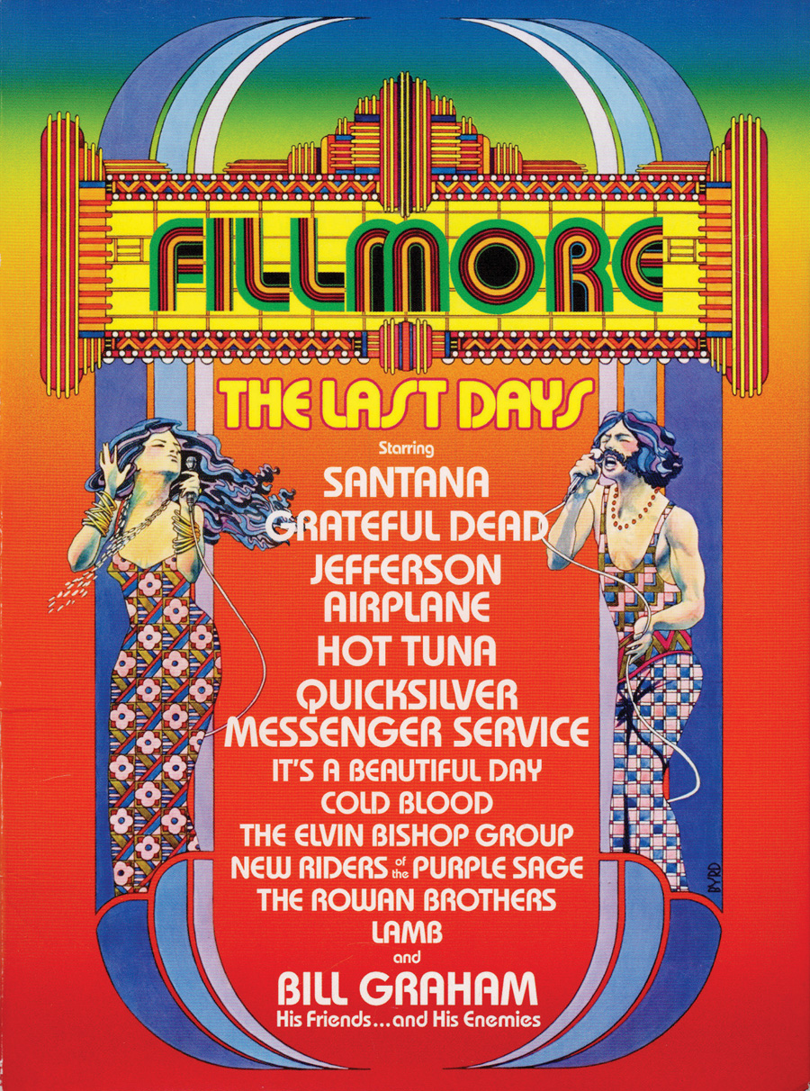
Calendar Editors, please note:
Friday, October 20 at 6:57 PM.
Lobero Theatre

GO TO HALE: FILM SERIES 2
Bill Graham: His Friends… and his Enemies
Fillmore: The Last Days

Legendary concert promoter Bill Graham brought together some of the biggest acts of the 60’s on through the 90’s, captured in the phenomenal concert film, Fillmore: The Last Days. Recorded at the Fillmore West in San Francisco from June 29 to July 4, 1971, the film contains performances by bands including SANTANA, THE GRATEFUL DEAD, JEFFERSON AIRPLANE, HOT TUNA, QUICKSILVER MESSENGER SERVICE, and the NEW RIDERS OF THE PURPLE SAGE. Come for the Fillmore lore; stay for the Quips & Clips. Please note: Content is subject to change without warning. https://www.lobero.org/events/go-hale-oct-20/

Please note: Content is subject to change without warning.

Tickets: $17.50. Includes facility fee.

Lobero Box Office: www.Lobero.com, 805.963.0761, 33 East Canon Perdido Street, Santa Barbara, CA 93101

