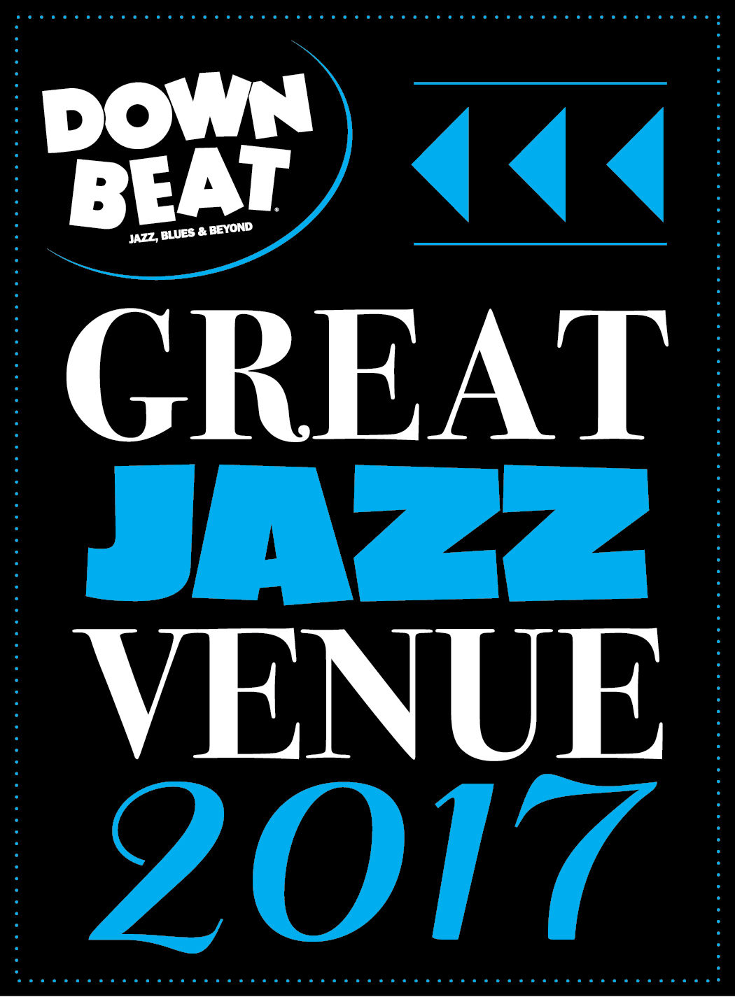

FOR IMMEDIATE RELEASE

Press Contact: Angie Bertucci

805.679.6010 / [abertucci@lobero.org](mailto://abertucci@lobero.org)

Tickets: Lobero Box Office

805.963.0761 / [lobero.org](http://www.lobero.org)

Jazz at the Lobero presents  
HUDSON

Jack DeJohnette · Larry Grenadier · John Medeski · John Scofield

Friday, June 9 at 8 PM

Jack DeJohnette is regarded as one of the finest living jazz drummers. – *The Los Angeles Times*

Scofield’s muse has evolved from guitar standards to post-bop to fusion and back again. – *DownBeat*

John Medeski has been bringing jazz and fusion to rock audiences for more than two decades. – *NPR*

[Larry Grenadier is] a deeply intuitive bassist – *The New York Times*

*Santa Barbara, CA, May 15, 2017* – Jazz at the Lobero welcomes jazz supergroup HUDSON to the Lobero on Friday, June 9 at 8 PM. Music Giants Jack DeJohnette, Larry Grenadier, John Medeski, and John Scofield have joined Forces as Hudson, releasing their first album together this June. Fans know them as hard swinging jazz masters; deft and creative jam purveyors, rocking funky groove maestros, each musician at the top of his game.

This all-star band calls themselves Hudson, named after the Hudson River Valley they each call home. Drummer Jack DeJohnette, bassist Larry Grenadier, keyboardist John Medeski, and guitarist John Scofield team up to celebrate their musical histories and Jack’s 75th birthday year in a tour de force of creative interplay. Fans know them as hard swinging jazz masters; deft and creative jam purveyors, rocking funky groove maestros, each musician at the top of his game. It’s rare that so impressive a group of individuals finds time away from their own projects to tour together. True to the spirit of the project’s name, they have collected a repertoire of Hudson Valley materials from Bob Dylan and The Band to the Woodstock Festival’s Joni Mitchell anthem and blues-rock-soul from Jimi Hendrix. Their June 2017 album release and performances will feature original compositions as well, inspired by their surrounds and each other. This is a band with wide ranging appeal.

Tickets for [HUDSON: Jack DeJohnette · Larry Grenadier · John Medeski · John Scofield](https://www.lobero.org/events/hudson/) are on sale now at [Lobero.org](https://checkout.lobero.com/single/SelectSeating.aspx?p=10014) calling the Lobero Box Office at 963.0761. Section A tickets are $60, section B $50 and a limited number of VIP tickets are available for $105. Prices include facility fees. VIP tickets include premier seating and entry into pre-performance reception. Jazz at the Lobero Series subscribers enjoy priority seating, savings on single ticket prices, and advance updates on upcoming shows. New series announcement coming soon!

Brubeck Circle Members enjoy an exclusive 20% discount on all Jazz at the Lobero shows–even those offered outside the series. The Lobero Brubeck Circle makes it possible for the Lobero to bring amazing jazz, blues and roots artists like Wayne Shorter, Dr. John, Chris Thile, Robert Cray, and Keb’ Mo’ to the Lobero stage. This core group of donors also supports efforts to create the jazz audiences and fans of tomorrow through educational outreach programs. Learn more about the Lobero Brubeck Circle at [Lobero.org/Jazz](http://www.lobero.org/tickets/jazz/) and become a member by designating a gift of $100 or more to jazz at [Lobero.org/Donate](http://checkout.lobero.com/dev/contribute.aspx).

*Downbeat Magazine* has recognized the Lobero Theatre in their 2017 [guide to Great Jazz Venues](http://downbeat.com/digitaledition/2017/spcvenueguide/56-57.html). This is the Lobero’s seventh year on this prestigious list – which also includes venerable institutions such as the Blue Note, Preservation Jazz Hall and Yoshi’s. From its incredible inaugural season in 2000, that featured Chick Corea, Wynton Marsalis, Wayne Shorter and Herbie Hancock on through groundbreaking performances by the Preservation Hall Jazz Band last year, Jazz at the Lobero has provided a wealth of memorable musical moments.

COMING UP FROM LOBERO LIVE:

David Lindley

Saturday, August 26

Throughout this long and distinguished career, David Lindley has been one of the world's most in demand session musicians, lending his skills to the recorded works of Bob Dylan, Rod Stewart, Linda Ronstadt, Crosby, Stills and Nash, Warren Zevon, Ben Harper and many others.

An Evening with Leo Kottke

Sunday, September 17 at 7 PM

Famed acoustic player Leo Kottke is known for a fingerpicking style that draws on blues, jazz, and folk music, and for syncopated, polyphonic melodies. Kottke overcame a series of personal obstacles, including partial loss of hearing and a nearly career-ending bout with tendon damage in his right hand to emerge as a widely recognized master of his instrument.

# # #

Lobero LIVE is sponsored by the Santa Barbara County Arts Commission, the *Santa Barbara Independent* and KCSB 91.9 FM. Lobero LIVE is funded in part by the Events and Festivals Program using funds provided by the City of Santa Barbara in partnership with the Santa Barbara County County Office of Arts & Culture. Sponsorship for Jazz at the Lobero is provided by the Lobero Theatre Endowment for American Roots Music, *Voice Magazine*, Union Bank, and the Lobero Brubeck Circle of Donors.

**­Calendar Editors, please note:**

**Friday, June 9 at 8 p.m.**

**Lobero Theatre**

**Jazz at the Lobero presents**

**HUDSON**

**Jack DeJohnette · Larry Grenadier · John Medeski · John Scofield**

Fans know them as hard swinging jazz masters; deft and creative jam purveyors, rocking funky groove maestros, each musician at the top of his game.

*Tickets: $105 – VIP / $60 – Section A / $50 – Section B. Prices include facility fee.*

Lobero Box Office: www.Lobero.org, 805.963.0761, 33 East Canon Perdido Street, Santa Barbara, CA 93101