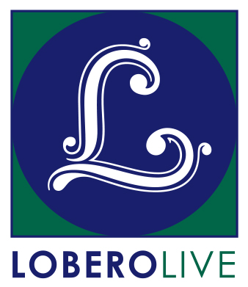
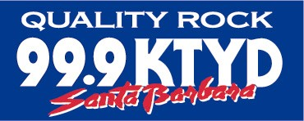
GO TO HALE: Film Series 2
Friday Nights To Remember At The Lobero Theatre

- Friday, June 16 – Quips & Clips vol. 5: All HALE! Rock ‘n Roll
- Friday, August 11 – Neil Finn & Friends “Seven Worlds Collide/The Sun Came Out”
- Friday, October 20 – Bill Graham… His Friends and his Enemies “Fillmore: The Last Days”

Santa Barbara, CA, May 12, 2017 – Rock ‘n roll fan and music lover Hale Milgrim is back with ANOTHER carefully-crafted series of special evenings featuring rare concert footage and insider stories with some (OK, a lot) of help from his friends. Join Hale for a visual, musical journey over the last 50 years complete with his memorable insights, commentary and illumination. Or not.

Milgrim’s own musical journey started behind the counter at Isla Vista’s Discount Records, and has spiraled upward through a succession of positions at major record labels, leading eventually to a stint as the President/CEO of Capitol Records. Since returning to Santa Barbara with his wife Anne, he has continued to work and support local music (including Sings Like Hell), and hosted a Sunday radio show, “Go to Hale,” which aired for over six years on KTYD.

Shows begin at 6:57 PM sharp, which means doors open at 6:27 PM. Seating is general admission, so be sure to get here beginning at 6:03 PM on the Esplanade for pre-show refreshments, auction and memorabilia for sale, and other fun stuff from Lobero LIVE and KTYD. All proceeds benefit live music at the Lobero Theatre.

Tickets for the Go To Hale Film Series 2 are on sale now at the Lobero Box Office at Lobero.org or by calling 805.963.0761. Single tickets are $17.50 each or save big and purchase the series for $39–That’s almost one free show! The Lobero is offering a $75 special “I’m with the Band” series, which includes seats in the VIP Reserved Section and a donation to the Lobero Theatre to support live music.

Friday, June 16 - Quips & Clips vol. 5
All HALE! Rock ‘n Roll

Hale has carefully curated an evening of Quips and Clips direct from his extensive archives. You may get a glimpse of artists like: The Quarrymen, Glimmer Twins, You Two, YNSC, Jah Bob, CBerry, and The Warlocks–plus so many more they wouldn’t fit here. Please note: Names have been changed to protect the innocent. Content is subject to change without warning.

Friday, August 11 – Neil Finn and Friends
7 Worlds Collide / The Sun Came Out

Crowded House frontman Neil Finn has recorded many successful solo albums as well as assembled an amazing cast of musicians for the 7 Worlds Collide project, a live recording & concert film culled from a series of five shows recorded at the St James theatre in New Zealand in 2001. Watch for RADIOHEAD’S Ed O’Brien and Phil Selway, PEARL JAM’S Eddie Vedder, THE SMITHS’ Johnny Marr, WILCO’s Jeff Tweedy, Glenn Kotche, John Stirratt and Pat Sansone. PLUS, KT Tunstall, Tim Finn, Liam Finn, (and even more Finns) and lots of Hale’s patented Quips & Clips! Please note: Content is subject to change without warning.

Friday, October 20 – Bill Graham: His Friends… and his Enemies
Fillmore: The Last Days

Legendary concert promoter Bill Graham brought together some of the biggest acts of the 60’s on through the 90’s, captured in the phenomenal concert film, Fillmore: The Last Days. Recorded at the Fillmore West in San Francisco from June 29 to July 4, 1971, the film contains performances by bands including SANTANA, THE GRATEFUL DEAD, HOT TUNA, QUICKSILVER MESSENGER SERVICE, and the NEW RIDERS OF THE PURPLE SAGE. Come for the Fillmore lore; stay for the Quips & Clips. Please note: Content is subject to change without warning.

# # #

Go to Hale enjoys generous sponsorship from KTYD 99.9 FM. Lobero LIVE is sponsored by the Santa Barbara County Arts Commission, the Santa Barbara Independent, and KCSB 91.9 FM. Funded in part by the Events and Festivals Program using funds provided by the City of Santa Barbara in partnership with the Santa Barbara County Arts Commission.

