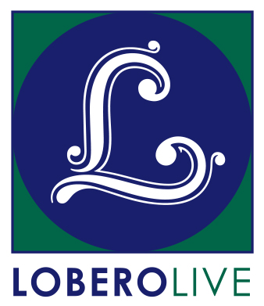
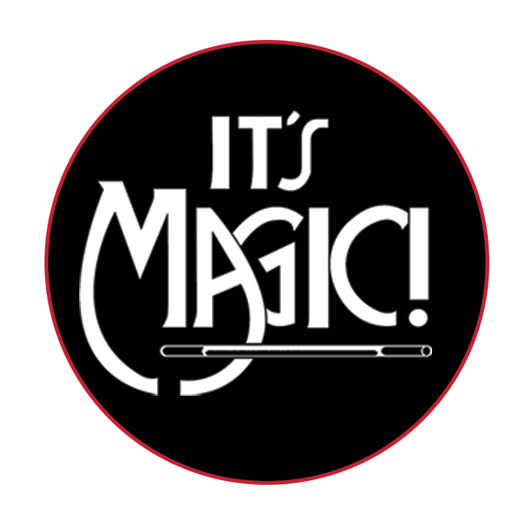
For Immediate Release

Press Contact: Angie Bertucci
805.679.6010 / abertucci@lobero.org
Tickets: Lobero Box Office
805.963.0761 / lobero.org

Lobero LIVE presents IT’S MAGIC!
Sunday February 19 at 2 PM & 6:30 PM

• America’s longest-running magic revue celebrates 20 years of comedy and magic at the Lobero Theatre
• Each year is an all new show with top magicians from all over the world

Santa Barbara, CA, January 23, 2017 – Lobero LIVE is proud to present It’s Magic! on February 19 at 2PM and 6:30 PM. America’s longest-running magic revue returns to the Lobero to dazzle audiences with an all-new lineup of top illusionists direct from exotic showrooms and Hollywood’s famous Magic Castle. You won’t believe your eyes as top magicians perform incredible feats, from jaw-dropping sleight of hand and off-beat comedic magic to mind-boggling full stage illusions. This one-of-a-kind magic show that has been delighting magic fans for more than five decades, and is sure to be a treat for the whole family. See why the LA Times has called it, “The liveliest lineup of magic acts this side of Las Vegas!”

It’s Magic! will be appearing at the Lobero Theatre on February 19 for two performances. Tickets are on sale now at the Lobero Theatre Box Office, Lobero.org, or by calling 805.963.0761. Tickets are $20 for children, and $29 section B/ $35 section A for adults, with a limited number of VIP tickets available at $80. All prices include facility fee. VIP tickets include priority seating, and entry to a private reception before the 2 PM performance.

Get your tickets today, before they disappear…

About It’s Magic!
The tradition of an all-star magic show started in 1956 when two young entrepreneurs, Milt Larsen and Oliver Berliner, produced a show called Hocus Pocus ‘56. At first, the shows played for a very limited time only, but as the number of fans grew, the number of performances was expanded. This gave Larsen the idea of forming a full-time private club for magicians and magic enthusiasts, and thus was born the Magic Castle, a private club for magicians and magical enthusiasts that opened its doors in 1963. Terry Hill, a longtime Magic Castle member, made the point that although magicians could be seen throughout the year at the Castle, the public rarely had a chance to see these great performers. Also, the Castle had stage limitations and was restricted to audiences over twenty-one years of age. There was a real need for an exciting full evening family-friendly show like It’s Magic!

Jody Baran & Kathleen
Jody Baran and Kathleen are a world-renowned illusion team who has traveled around the globe proving that magic can transport wherever you wish. Bringing aboard their original illusions to ocean liners from the Atlantic to the South Pacific they have mesmerized adults and children alike with their magic and wonder. By the turn of the 21st century magic featured "the Baran touch", and was seen at corporate events theme parks and in hotels. They just completed a 16 year run with their magic illusion dinner show called, "Kupanaha" Maui's Magic for all Ages on the island of Maui.

Juliana Chen
Juliana Chen was born and raised in the Hunan Province of the People's Republic of China, and has gone on to success in magic across the globe. As a child, Chen was selected for specialized training at the Hunan Academy for the Performing Arts. After a couple of accidents, Juliana was advised by doctors to give up foot juggling. While she was recovering, Japanese magician Shimada, and the way he had integrated magic into his Asian culture fascinated her. The Guangzhou troupe's manager encouraged Juliana to develop as a magician. Some four years later in 1986, she was recognized as the best magician in China when she won the All-China Best Magician competition.

Over the next several years, Juliana won numerous magic competitions in Canada and Europe, including the World Championship at the World Congress of Magicians (FISM) in Dresden, Germany. Juliana became the first woman, and first magician of Chinese heritage, to win gold with a solo act. In the Spring of 2003, Juliana was nominated for Stage Magician of the Year by the Academy of Magical Arts in Hollywood. Since winning the world championship, Juliana's career has blossomed around the world. One of Juliana's most important backstage successes has been opening the doors in China and the West for the exchange of magicians. Juliana's initiative eventually led to a substantial growth in China's involvement in international magic events culminating with Beijing hosting the World Championships of Magic in 2009.

Charlie Frye & Co.
Acknowledging America's rich vaudeville tradition, Charlie Frye & Company synthesize virtuosic skills and a passionate love of their art into something classic yet undeniably fresh–something that astounds even as it entertains. For the last twenty-odd years (some odder than others), Charlie and his wife Sherry have been delighting audiences worldwide with their singular blend of silent comedy, magic, juggling, slapstick, and acrobatics. Charlie is often compared to classic comedians such as Charlie Chaplin, Buster Keaton, Stan Laurel and Dick Van Dyke.

Together, they have thrilled audiences in many exotic venues around the world, including Australia, Africa, Europe, Asia. Besides being one of the world’s most sought after American specialty acts, they are also in constant demand throughout the United States, where they were named Las Vegas’ Specialty Act of the Year for their star billing in the Folies Bergere. Other prestigious appearances have included opening for Liza Minnelli, starring in the internationally syndicated television special, "The World's Top Shows", and a featured appearance in Tom Hanks' film, "That Thing You Do." Recent honors include the coveted 2015 Ken Dodd Comedy Award in England, and the 2015 Award of Excellence from the International Jugglers’ Association. Whether it’s theatre, showrooms, television, or corporate events, Charlie Frye & Company never fails to keep audiences laughing and applauding all at once.

Jay Johnson
"Where's Bob?" It's a question Jay Johnson hears often, at airports, in restaurants or just walking down the street. It's an obvious question to the millions of people who know Jay from television. It's a great compliment to Jay Johnson's artistic ability as one of the world's greatest ventriloquists, to have people ask about his wooden partners.

Jay started performing at 11 years old when he discovered his natural ability to make a cousin's doll come to life and began a career using his imagination. His acute dyslexia disappeared in this world where he was able to find his self esteem. In high school he produced and starred in his own local television show sponsored by a car dealership. This led to summers performing in theme park shows at Six Flags over Texas, Six Flags over Georgia and Astroworld. In the mid 70's Jay moved to Los Angeles to pursue his ideas for television. He has done over thirty national commercials, hosted three comedy specials, produced and performed in two network television specials, two HBO specials, hundreds of guest appearances on variety shows and starred in four television series ("Soap"). However, nothing he has done on television can compare to the thrill of seeing Jay perform live as thousands of comedy club audiences will tell you. His particular talents are best suited for live and spontaneous interchanges. His quick wit and unbelievable technique are pure magic when witnessed first hand.

Kyle Knight & Mistie
Las Vegas based illusionists, Kyle Knight and Mistie, have traveled the world sharing their own unique style of illusions, and giving their audiences a completely different perspective of the art of magic. Together Kyle and Mistie utilize video screens for a close up view of sleight of hand, demonstrate amazing mental miracles, and perform their illusions with a bold and modern style and a touch of irreverence.

Kyle Knight became interested in the art of magic at a young age, and during his teen years he was hired to teach magic courses at the local university. Performing magic to pay his way through college, Kyle broadened his talents and earned a degree in video and television production. He has been recognized by the Society of American Magicians, the International Brotherhood of Magicians and the Houdini Society, and has received numerous first place awards in magic competitions for his skills in sleight of hand, escapes, and stage illusions.

Mistie Knight has been Kyle’s better half and Knight Magic’s leading lady for 12 years. She is involved in every aspect of the show; adding personality and production with her own magic, choreography, piano performances and costume quick changes. Representing the “Entertainment Capital of the World,” Mistie was honored to be crowned Miss Las Vegas 2006, and Miss Nevada 2007.

Tickets for It’s Magic! are available now at Lobero.org, and at the Lobero Theatre Box Office by calling 805.963.0761. Tickets are $20 for children, and $29 section B/ $35 section A for adults, with a limited number of VIP tickets available at $80. All prices include facility fee. VIP tickets include priority seating, and entry to a pre-performance private reception before the show (2 p.m. performance only).

# # #

Lobero LIVE and Lobero Youth & Community programs are sponsored by the Santa Barbara County Arts Commission, the Santa Barbara Independent, Montecito Bank & Trust, The Lobero Theatre Associates, Union Bank, Elaine F. Stepanek Foundation, Brown Family Foundation, Harold McAlister Charitable Foundation, Nichols Foundation
Calendar Editors, please note:
Sunday, February 19 at 2 & 6:30 PM
Lobero Theatre

Lobero LIVE presents
It’s Magic!
America’s longest-running magic revue returns to the Lobero to dazzle audiences with an all-new lineup of top illusionists direct from exotic showrooms and Hollywood’s famous Magic Castle.

Tickets for It’s Magic! start at $20/Children, $29-$35/Adults & a limited number of VIP tickets available for $80. Prices include facility fee. https://www.lobero.org/events/its-magic-2017/

www.lobero.org, Lobero Box Office 805.963.0761, 33 East Canon Perdido Street, Santa Barbara, CA 93101

